Lab 10
- Identify the absolute path of your home directory.

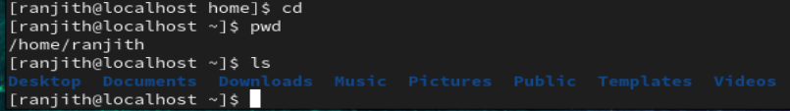
- Navigate to a directory using its absolute path.
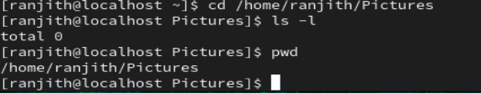
- Navigate to the same directory using a relative path.
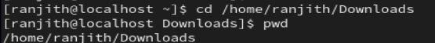

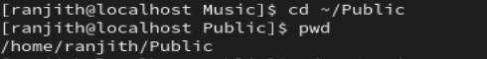

- Move back to the home directory using a relative 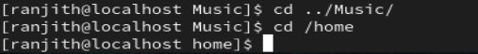path.

- Observe the difference between absolute and relative paths.





- Write down one example of an absolute path.
cd /home/ranjith/Downloads
step by step moving the directory in single command
source to destination also implemented in the same command

- Write down one example of a relative path.
cd ../Pictures
shift to one directory to another directory to moving or moves you up one directory level

lab 11

- Create a file named `file1.txt`.
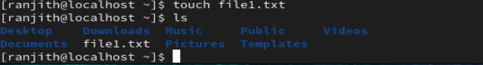
- Copy `file1.txt` to a file named `file1_backup.txt`.
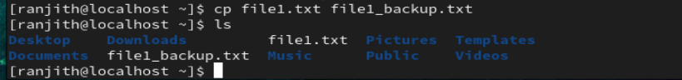
- Create a directory named `data`.
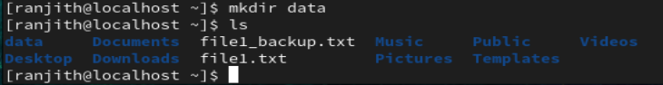
- Copy `file1.txt` into the `data` directory.
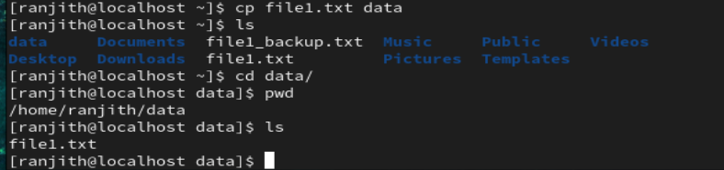
- Create another directory named `backup`.
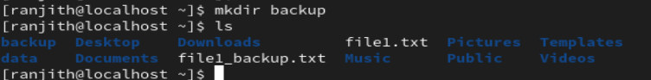
- Copy the entire `data` directory into `backup`.
- Verify that the copied files and directories exist.
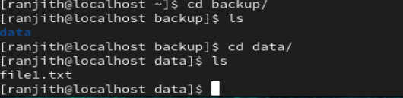

Lab 12
- Create a file named `oldname.txt`.
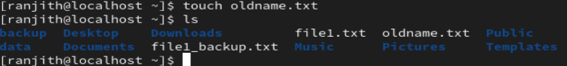
- Rename `oldname.txt` to `newname.txt`.
- Create a directory named `docs`.
- Move `newname.txt` into the `docs` directory.
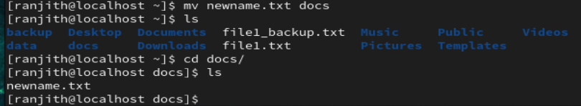
- Create a directory named `archive`.
- Move the `docs` directory into `archive`.
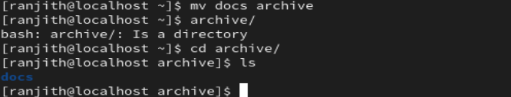
- Verify the new location of files and directories.
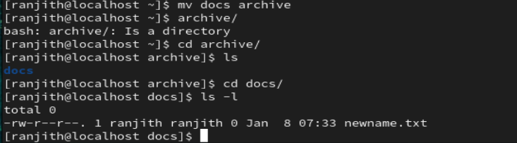

Lab 15
- Create a directory named `project`.
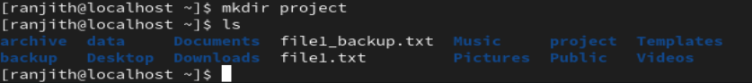
- Inside `project`, create a file named `readme.txt`.
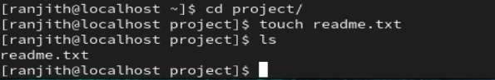
- Navigate to `project` using an absolute path.
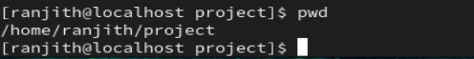
- Navigate back using a relative path.
